General Submission Guidelines
for JEICOM
(Please delete once read and followed—but before submitting your paper.)

Guidelines for paper preparation
This document illustrates the required layout for your full paper. Please maintain the same font, formatting, and positioning as presented here. The paper should not exceed 5,000 words in total (including references). Exceptions may be granted by the journal editors for papers of exceptional research excellence.
Authors are expected to:
- Clearly present and define any technical terms or uncommon concepts for the target readership.
- Write out acronyms in full upon first mention, followed by the abbreviation in parentheses.
- Submit manuscripts that are carefully written, proofread, and free of spelling, grammar, and usage errors.

The template embedded in this example document should be applied through the “Styles” feature of Microsoft Word. Using the template allows automatic updating of styles and other elements should changes be necessary. The template can be downloaded and saved to your template folder. In general, the template can be used in two main ways:
- applied to an existing document, or
- Used as the basis for creating a new document.
Alternatively, the template document itself can be modified by substituting your information for the example information provided. Appendix 1 lists styles used by this template. [Click on “Styles Pane” and check “Show style guides” to view styles used for each template item.]
Formatting Specifications

- Page size: A4, with 2 cm margins (left, right, top, and bottom).
- No page numbers should be included.
- Main text: 12-point Times New Roman, fully justified.
- Spacing: 1.15 line spacing for all text, with an additional 6-point space after each paragraph.
- References, footnotes, and additional comments: 12-point Times New Roman, left-justified (not fully justified) due to spacing considerations.
- Headings and subheadings: follow the template styles.
- Emphasis: use bold text sparingly for key terms or phrases.
- Tables, figures, and appendices: adjust formatting as needed to suit content.

(Prepare a separate Word document for the title/abstract page
to allow for blinded peer review;
follow this page of the template)

Full Paper Title
(Times New Roman, 14)

Author’s Name and Surname , 1st co-author’s Name and Surname (if applicable) , and 2nd co-author’s Name and Surname (if applicable)

Abstract

The abstract should present the aim/objectives of your work, the methodological approach, the results, and the basic conclusions. The length should not exceed 300 words. Use only one paragraph.
Keywords
Please provide up to the five most representative keywords. Keyword 1, Keyword 2, Keyword 3, Keyword 4, Keyword 5.

(The above section is requested on a separate Word document from the full document,
to allow for blinded peer-review. The other paper-that does not contain your data-should be saved and uploaded as blinded for the purposes of the blind review.)
Full Paper Title
(Times New Roman, 14)

Abstract
The abstract should present the aim/objectives of your work, the methodological approach, the results, and the basic conclusions. The length should not exceed 300 words. Use only one paragraph.
Keywords: Please provide up to the five most representative keywords. Keyword 1, Keyword 2, Keyword 3, Keyword 4, Keyword 5.

Citation
Bonk, R., Kefalaki, M., Rudolph, J., Diamantidaki, F., Rekar Muno, C., Karanicolas, S., Kontoleon, P. & Pogner, K.-H. (2020). Pedagogy in the time of pandemic: From localisation to glocalisation. Journal of Education, Innovation and Communication, 2 (SI1). DOI: https://doi.org/10.34097/jeicom_SP_june2020_0 [journal article])

Introduction
Provide the context for the study amid any current debate. Develop an academic discussion of the relevant theories and literature of the chosen discipline; aim to emphasise the most recent and salient developments in the field. Share the theory that underpins the research study adopted and any model that you followed to help with the methodology of the work and discussion of the data.

Methodology
Describe the process of collecting data during the research. Qualitative analysis is a predominant tool in social research and probably the main one used when discussing the data collection tools, alongside the quantitative or mixed-methods approach. In any case, this section should demonstrate the tools, sampling, processes of interpreting data, and ethical considerations.

Results

Text description
Present data according to the theoretical framework adopted in the previous section and its outlined methodology. Data should be critically assessed to show how this research advances the field. Tables, figures, and appendices should be kept to a minimum due to space considerations.

Tables and figures
Tables and figures are referred to and included within the main text; bulky materials should be relegated to an appendix. Other key points follow [example of block text]:
Each table, figure, or appendix should be numbered consecutively (in Arabic numerals) and titled. Tables and figures should be placed close after their first reference in the text; appendices follow the reference section. Captions should be sufficiently explanatory separate from the main text.
Table captions should be centred above the tables, whereas figure captions should be centred below the figures, as shown in the following examples. When possible, minimize excessive use of vertical or horizontal rulings. Use explanatory notes for any additional information.

Example of table
Table 1: Statistical Parameters by Model
Model * | CFI | TLI | RMSEA
Single-common factor | 0.772 | 0.744 | 0.104
Two-factor | 0.886 | 0.893 | 0.060
Six-factor | 0.811 | 0.787 | 0.106
Revised five-factor | 0.954 | 0.943 | 0.042
* See Methodology for delineation of factors for each model.

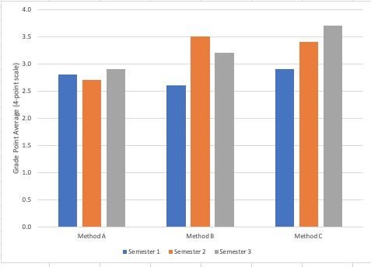
Example of figure

Figure 1: Comparison on Intervention Methods on Grade Point Average

Example of appendix
Appendix 1, following the reference section, also lists the styles used within this template.

Conclusions
Concisely state the most important propositions of the paper as well as the author’s views of the practical implications of the results. Limitations of the current study should be identified, as well as future research on the topic of the paper.

Acknowledgments
Please place acknowledgments, if any, here.

References
Papers should be supported by references set out according to the APA referencing style (7th edition). In the text, references should be cited by the author’s name and year of publication in parentheses—for example, “(Whitney & Rolfes, 2011)” or “as noted by Whitney & Rolfes (2011)”.
The reference list, placed at the end of the manuscript, must be typed in alphabetical order of the last name of the first/main author. If authors have more than one publication, order by publication date—oldest to newest. If there is no author, the title moves to that position, and the entry is alphabetised by the first significant word (i.e., excluding words such as “A” or “The”). If the title is long, it may be shortened when citing in the text.
Format references with hanging indentation. Do not create separate lists for each type of source. Books, articles, web documents, brochures, etc. are all arranged alphabetically in one list.
Italicise titles of books, titles of journals/serials, and titles of web documents. Only Titles for journals should be capitalised for each major word. Selected examples follow [genre in brackets]; however, refer to the APA Style Guide (7th edition) for full details.
You can ensure you include all DOIs in the reference list by using this link: https://apps.crossref.org/SimpleTextQuery which allows you to submit your list and it returns any DOIs. This is important from a CrossRef compliance context.

Example Reference [Genre]
Aspinall, V. (Ed.). (2014). Clinical procedures in veterinary nursing (3rd ed.). Elsevier. [edited book]
Collier, A. (2008). The world of tourism and travel. Pearson Education New Zealand. [authored book]
Communication Institute of Greece. (2019, February 27). EDU 2021 call for papers. https://coming.gr/edu2021-call-for-papers/ [organization website]
Bonk, R., Kefalaki, M., Rudolph, J., Diamantidaki, F., Rekar Muno, C., Karanicolas, S., Kontoleon, P. & Pogner, K.-H. (2020). Pedagogy in the time of pandemic: From localisation to glocalisation. Journal of Education, Innovation and Communication, 2 (SI1). DOI: https://doi.org/10.34097/jeicom_SP_june2020_0 [journal article]
MacColl, F., Ker, I., Huband, A., Veith, G., & Taylor, J. (2009, November 12-13). Minimising pedestrian cyclist conflict on paths. Seventh New Zealand Cycling Conference, New Plymouth, New Zealand. http://cyclingconf.org.nz/system/files/NZCyclingConf09_2A_MacColl_PedCycleConflicts.pdf [conference paper]
Palmer, F. (2007). Treaty principles and Maori sport: Contemporary issues. In C. Collins, & S. Jackson (Eds.), Sport in Aotearoa/New Zealand society (2nd ed., pp. 307-334). Thomson. [book chapter]
Appendix 1: Styles Used in Full Article Template for JEICOM
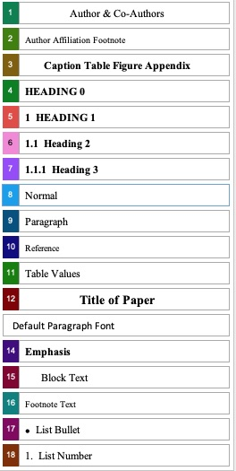

General Submission Guidelines
for JEICOM
(Please delete once read and followed—but before submitting your paper.)

Submitting your paper
Please submit your full author-details document and your full paper (blinded) on the online platform of Open Publishing at https://open-publishing.org/journals/index.php/jeicom

For the document with your author’s details and affiliations:
JEICOM_YOUR LAST NAME (First Author's name only)
For example: JEICOM_KEFALAKI.doc

For the full paper without your author’s details and affiliations:
JEICOM _ BLINDED_ THE THREE FIRST WORDS OF THE ARTICLE’S TITLE

Last but not least, please respect the author guidelines mentioned at https://open-publishing.org/journals/index.php/jeicom/information/authors, as well as any other(s) specified during the peer-reviewing process. Any communication with the editors is taking place via the Open Publishing platform. JEICOM retains the right to refuse publication in case authors do not conform to these guidelines. Thank you.

Position, Affiliation, Department, University, Address, Country, e-mail: ...
Position, Affiliation, Department, University, Address, Country, e-mail: ...
Position, Affiliation, Department, University, Address, Country, e-mail: ...

