

**An interactive and adaptive learning resource for teaching first year human anatomy**

Associate Professor Kelly Linden  
Charles Sturt University, Australia;  
Dr Sarah Teakel  
Charles Sturt University, Australia

# Abstract

**Editors**

Section: Educational Technology  
Senior Editor: Rachel Fitzgerald  
Associate Editor: Jianhua Yang

**Publication**

Received: 1 May 2024  
Accepted: 4 Oct 2024  
Published: 21 Oct 2024

**Copyright**

© by the authors, in its year of first publication. This publication is an open access publication under the Creative Commons Attribution [CC BY-ND 4.0](https://creativecommons.org/licenses/by-nd/4.0/) license.

Anatomy is a particularly challenging unit in many first-year university courses, however adaptive learning resources provide an opportunity to engage students in practical-based units such as anatomy. Here, the impact on student engagement, student learning and exam preparedness of implementing 21 interactive online adaptive lessons was evaluated. A total of 276 first-year students, enrolled in allied health undergraduate degrees from 2016 to 2020, consented to participate in this mixed methods study. Our findings suggest a positive correlation between the number of lessons a student completed and a positive performance in each of the three assessment items in the unit (p<0.05). We also identify an increase in students perceived understanding of anatomy after completing the lesson (p<0.0001). Students worldwide appreciate individualised, flexible and engaging nature of learning technologies. Here, we evidence that students appreciated online adaptive lessons to learn anatomy and exhibited a high level of satisfaction.

## Citation

Linden, K., & Teakel, S. (2024). An interactive and adaptive learning resource for teaching first-year human anatomy. *Journal of University Teaching and Learning Practice, 21*(6). <https://doi.org/10.53761/rsvewq08>

## Practitioner Notes

1. Online adaptive lessons can provide an engaging and flexible study tool for learning human anatomy.
2. Contemporary online and adaptive learning resources increase learner engagement present a unique way to address challenges in teaching large, practical-based units such as anatomy
3. Students appreciate individualised, flexible and engaging learning facilitated by technologies.

# Introduction

A thorough understanding of human anatomy is necessary for medical and allied health professionals. However, human anatomy courses have been identified as challenging (Langfield et al., 2018) and can have high failure and withdrawal rates (Bruno et al., 2016). One reason is simply that anatomy is often taught in the first year of university study, a time when students are transitioning and learning to navigate university systems (Kift, 2015) and students may not be academically prepared to study anatomy in their first year (Bruno et al., 2016). In addition, there are discipline-specific factors such as the volume of new information and unfamiliar terminology (Langfield et al., 2018). Traditionally, human anatomy has been taught using lectures, tutorials and laboratory classes. However, laboratory-based, cadaver instruction has remained the gold standard for learning anatomical knowledge for hundreds of years (Estai, 2016). It is known that cadaver-based instruction can be initially confronting for students, although this stress usually diminishes over time and students appreciate the learning experience (Hancock et al.,1998). To maximise student success, it is likely the best way to teach modern anatomy is to use a combination of pedagogical strategies. Contemporary online and adaptive learning resources that are designed for high engagement, yet are flexible to the needs of learners, present a unique way to address challenges in teaching large, practical-based units.

Adaptive learner-centred learning platforms allow for variation in the pathway that a student moves through content, based on individual students’ responses and activity. The lessons are structured to provide instant feedback and adapt in real time (Oxman & Wong, 2014). In 2018, the New Media Consortium Horizon Report estimated that adaptive learning would be impacting high education within 2-3 years and is an important development in educational technology (New Media Consortium Horizon Project, 2018). It is widely recognised that, when possible, cadaver-based instruction is an important component of the anatomy curriculum (Estai, 2016; Patel & Moxham, 2006). However, contemporary online adaptive learning resources have the potential to provide deep and rich engagement with the content, while at the same time assisting students’ learning through visualisation and embedded feedback (Yakin & Linden, 2021). These resources can simulate anatomical structures and physiological processes, offering students a comprehensive understanding that is both theoretical and practical.

# Literature Review

There is a positive relationship between the use of learning technology, student engagement and learning outcomes (Chen, 2010; Wells et al., 2008; Wong, 2013). The right learning technologies or tools can facilitate student engagement and online learning (Hollister et al., 2022) and improvements to online learning have been significant and were accelerated during the rapid move to online study during the COVID-19 pandemic.

It is well documented that student engagement is a key element for learning and success (Diaz et al., 2021; Kahn, 2014; Sinatra et al., 2015). High quality learning resources can support student understanding of conceptual material, provide visual examples of practice and contextualise the broader learning experience (de Jong et al., 2013). Prior to the onset of the COVID-19 pandemic, interest in hybrid teaching in higher education was growing, however, the practical nature of anatomy makes it difficult to teach entirely online (Drake et al., 2009). As a result of the pandemic, academics reported the move to online teaching and resource development as an opportunity to upskill (Longhurst et al., 2020). Due to advances in technology, reductions in teaching time and increasing costs of cadaver-base instruction, universities have continued to increase their reliance on online anatomy resources.

Positioning flexibility as fundamental will foster inclusive and effective learning environments. Higher education institutions have enhanced flexibility in learning to accommodate diverse student needs, and increase accessibility, participation and success. However, students studying online have been reported to still have difficulty in managing their workload (Hollister et al., 2022). Although studies have highlighted a need for students studying online to use a variety of engaging technologies, recent literature demonstrates that online learning is not yet able to provide an environment in an equitable manner for all students (Hollister et al., 2022). Technical barriers impacting accessibility including availability of a stable internet connection and suitable electronic device need to be addressed (Antoninis et al., 2020; Hollister et al., 2022). Universities can leverage technologies to facilitate remote learning, making anatomical education accessible to a broader audience. Academics often use a multimodal approach to delivering anatomy (Estai, 2016). Students have increasingly demonstrated varied preferences regarding learning anatomy such as kinaesthetic and gamification (Ang et al., 2018; Khanal et al., 2019). A recent study showed students had perceived benefits of learning anatomy when Universal Design for Learning (UDL) was implemented (Dempsey et al., 2024). UDL constitutes a framework to remove learning barriers and guide classroom practices to increase students’ success, and to improve executive ability and cognitive skills (García-Campos et al., 2020). Students considered UDL to include a variety of teaching methods or modes of presenting information including cadavers, videos, models and computer programs. One study demonstrated that just over half of students preferred multimodal delivery of anatomy content (Khanal et al., 2019).

Feedback in higher education should be timely and relevant and studies demonstrate that interactive teaching and instant feedback facilitates student learning (Baashar et al., 2023).

Artificial intelligence (AI) has provided new possibilities for technology-enhanced and automated feedback in higher education. AI has the capacity to provide feedback to students in real time with a positive impact on students’ academic performance, increased student engagement and concentration (Wang et al., 2024). It is clear that students studying anatomy and physiology benefit significantly from instant feedback (Baashar et al., 2023; Kingston et al., 2023). It has been previously suggested that adapting anatomy videos into interactive tutorials could enable instant feedback opportunities for student learning anatomy (Langfield et al., 2018). Students who demonstrated low self-efficacy were more likely to engage with supplemental instructional videos, which were used for preparing for practical anatomy classes and revision providing an additional layer of support for students who may struggle with traditional learning methods (Langfield et al., 2018). This approach not only helps in reinforcing the material but also boosts students’ confidence in their abilities. This shift in focus is crucial for fostering a more active and engaged learning environment (Langfield et al., 2018). Overall, there is growing recognition that the development of self-efficacy and critical thinking skills are more important than passive learning of content. Active participation in the learning process is essential for deeper understanding and long-term retention. When developing online resources, it is clear that they should not only be engaging but should also provide flexibility and instant feedback.

The onset of the COVID-19 pandemic and the disruption of face-to-face learning across the world necessitated the rapid move to online learning and fast-tracked the development of many resources. Responses from universities teaching anatomy from across Europe were not dissimilar to other disciplines and relied on resources such as online workbooks, synchronous classes delivered via online meeting platforms and, in some instances, specialised online content such as 3D anatomy models and digitised cadaveric resources (Brassett et al., 2020; Longhurst et al., 2020). It became evident that none of these experiences developed at short notice could replace the face-to-face, practical-based experience of an anatomy teaching laboratory (Brassett et al., 2020). A main concern reported by academics was reduced student engagement due to decreased mandatory attendance and social engagement (Longhurst et al., 2020). At the same time, many body donor programs were also suspended or significantly reduced, at least in part due to the risk of receiving bodies infected with COVID-19, reducing the opportunity to teach in the laboratory when classes resume (Lemos et al., 2021). A national survey was conducted on undergraduate students in the United States of America during the move to online in response to the COVID-19 pandemic. A total of 79 percent of students reported ‘staying motivated’ as the most difficult aspect of the transition (Means & Neisler, 2020).

A number of studies have shown promising results in moving anatomy online using well-developed methodologies. Alkhowailed and colleagues (2020) reported that medical students were satisfied with virtual problem-based learning classes and recommended that they continue in the future (Alkhowailed et al., 2020). Online practical anatomy videos of cadaveric tissues followed by synchronous discussion in interactive online tutorials were also shown to be an efficient and engaging approach to replacing face-to-face anatomy teaching (Diaz et al., 2021).

There is an increasing body of literature supporting the successful use of online adaptive learning resources in science and health disciplines, and students’ perceptions of engagement and learning are consistently high. In a randomised control trial of medical students, perceived engagement and learning of diagnostic imaging was significantly higher when the content was taught using adaptive learning rather than traditional web resources (Wong et al., 2015). Nursing students reported increased understanding of first year physiology, while also reporting the adaptive lessons to be interesting and engaging (Linden et al., 2018). Adaptive learning has also been used to develop skills traditionally taught in the laboratory. Students reported that learning Western Blotting techniques in adaptive lessons was at least equivalent to the real laboratory (Polly et al., 2014). Dental students who accessed adaptive histology lessons, a skill previously perfected with a microscope, scored significantly higher on relevant exam questions. Students reported that the ability to practice and instant feedback improved their knowledge (Yakin & Linden, 2021).

Despite the many benefits, there are some limitations to adaptive learning. For example, adaptive learning is often used for lower level of Bloom’s taxonomy cognitive skills such as remembering and understanding. It is likely that higher levels of cognitive skills such as analysing, evaluating and creating are more suited to other activities (Morze et al., 2021). Another potential limitation of adaptive learning is that scaffolding and student support are not adjusted in accordance with students’ learning (Molenaar et al., 2012; Wu et al., 2018). This may be why some groups find that adaptive learning has no impact on student performance, despite students having a positive perception of the technology (White, 2020). In addition, there can be institutional challenge that must be addressed when implementing adaptive learning. Faculty can show resistance to technological change, the technology will not always align with institutional strategies and goals and to be successful, it requires leadership support (Mirata et al., 2020). Technological challenges that can be faced include managing real time data integration into systems and ensuring user friendly interfaces for both students and staff (Morze et al., 2021). Overall, despite the identified benefits, adoption of adaptive learning can be slow and costly (Mirata et al., 2020).

Based on extant literature and the fore mentioned benefits of online adaptive lessons, we hypothesise that they can provide an engaging study tool for learning human anatomy with enhanced flexibility when studying online. Here, we evaluate the impact of implementing interactive online adaptive lessons on student engagement, student learning and exam preparedness of allied health students studying a first-year introductory anatomy unit prior to the COVID-19 pandemic; between 2016-2020.

# Methods

## Participants

The participants were 276 first-year allied health undergraduate students enrolled in an introductory human anatomy unit (BMS171) in 2016 (n=71), 2017 (n=85) and 2019 (n=83) or 2020 (n=37). The students were enrolled in the Bachelor of Physiotherapy, Bachelor of Occupational Therapy, Bachelor of Podiatric Medicine or the Bachelor of Health and Rehabilitation Science degree. Ethics approval for this study was received from the Charles Stuart University Human Research Ethics Committee (HREC; Protocol numbers EC00116 & H16057).

## Development of adaptive lessons

The adaptive learning lessons were developed in the Smart Sparrow platform which was decommissioned in 2022 and are now housed with Argos (https://www.argos.education/). HTML5 technology was used to create 21 novel adaptive anatomy lessons, which included high resolution photographs of models (taken by the author) that cover over 95 percent of the 500 structures taught in the unit. All lessons were accessible from a landing page within the adaptive lesson platform, and available as a non-compulsory, supplementary resource. Two styles of high-quality lessons were designed to assist students with weekly practical classes and were assessed in a ‘practical’ exam (with a 50% weighting) at the end of the semester. The first ten lessons focused on building student knowledge with drag-and-drop style questions (Figure 1). The next ten lessons included short answer questions to type in the name of the anatomical structure, requiring a level of comprehension consistent with the content in the practical examination (Figure 1). A final lesson was created to enable students to complete a ‘simulated’ practical exam, which consisted of 100 short answer questions from all 10 teaching weeks. True adaptivity was built into the lessons in that students could select their path and return to the menu screen at any time. Immediate adaptive feedback was built into the tutorials and provided to students based on their individual responses. After a pathway was selected, such as muscles of the hand, students would have the option of reviewing short, high-quality revision videos filmed by the first author and Unit Coordinator before moving to the questions. Students had three attempts at each question before being given the answer and moving to the next. The correct spelling was required for all open-text questions at the request of the discipline groups.

In this study, efforts were made to mitigate the risk of negative relationships associated with online learning. Such efforts included careful scaffolding of the lessons, and increased opportunities for students to engage in critical thinking and support in class as Bloom’s lower-level activities were completed online and asynchronously. Early in the design process a number of different lesson formats were trialled. Student feedback was built in early in the process to improve the lessons in real time. Based on student feedback, the final lesson format most closely resembled the format of the practical exam and in many ways resembled formative assessments.

**Figure 1.** *Types of Questions in the Adaptive Online Lessons*

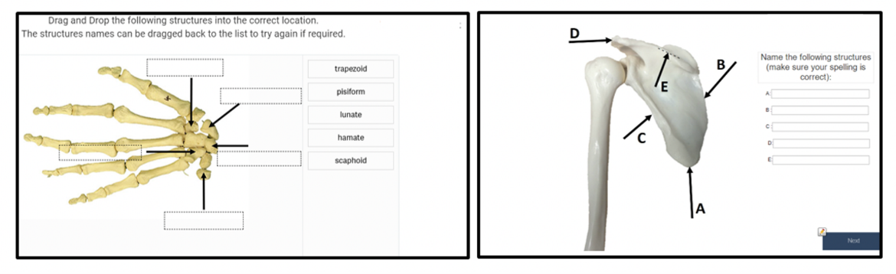

*Note.* This figure shows examples from the 21 adaptive lessons. Consistent with the practical exam, two styles of adaptive lessons were available; (i) drag-and-drop style lessons (left) and (ii) open text boxes for students to type in the name of the structure (right).

## Mode of study

All study participants had access to learning resources via the learning management system (LMS, Blackboard), including lecture recordings, lecture notes and online adaptive anatomy lessons. The unit was assessed with 10 weekly online quizzes each worth 1% (total value of 10%), a practical ‘flag’ exam held in the cadaver laboratory worth 50% and an end of session theory exam worth 40%. In 2020, the theory and practical exams were moved online and were housed in the LMS test environment (Test Centre).

In 2016, 2017 and 2019, of the students who consented to the study, there were 197 on-campus students (71 percent of all participants in the study) who attended weekly face-to-face lectures, tutorials, and a laboratory class where anatomical structures from the adaptive lessons were identified in the cadaver laboratory. During this time, 42 students (15 percent of all study participants) were enrolled online and attended a 5-day on-campus, mid-semester intensive practical. In 2020, all classes were moved online for the 37 students who participated in the study (13 percent of all study participants) in response to the COVID-19 pandemic and the subsequent rapid move to online study. No students completed the survey in 2018 due to academic/coordinator leave. The resources were not evaluated past the period of this study.

## Survey and interviews

Participants in the study evaluated the effectiveness of the adaptive online lessons for their learning by consenting to either (i) completing a survey (either online within the Smart Sparrow platform or paper-based) n=276, or (ii) making all assessment work available and granting access to the online learning analytics and grades (n=191). The survey contained a series of questions measured on a 5-point Likert scale (5=strongly agree, 4=agree, 3=neutral, 2=disagree, 1=strongly disagree) to evaluate students’ perceptions of the lesson structure, engagement and motivation, and student learning. Students were asked how many times they completed each of the interactive online lessons and the open-ended questions; ‘What did you find most useful’ and ‘What did you find least useful’. In addition, the Unit Coordinator consented to a semi-structured interview.

## Assessment marks and learning analytics

Assessment marks were downloaded from the LMS grade management platform (Grade Centre). Smart Sparrow learning analytics were downloaded as a .CSV file. Due to issues with data completeness, only the number of lessons accessed, and approximate average time spent on each lesson (noting issues with the system not logging out) are reported here.

## Statistical and thematic analysis

Group means were compared to students rating of their understanding of the content before and after the lessons using a paired Student t-test. Correlations between the mark for each assessment item and the number of online adaptive lessons completed or the performance in the practice practical exam lesson were analysed with a Pearson correlation coefficient utilising the statistical package GraphPad Prism version 9.3.1 (GraphPad Software, La Jolla, California, USA). The significance level was set at p<0.05. Qualitative analysis was undertaken on the open text comments from student responses using the thematic framework approach (Gale et al., 2013) and the transcript of the semi-structured interview with the Unit Coordinator was analysed using the NVivo 12 Qualitative Analysis tool. Initial codes were identified, discussed and refined. This framework was systematically applied to all transcripts. A matrix was used to summarise the individual participant data and group into themes.

# Results

On average, each student completed 15 of the 21 lessons (range: 1-21, n=191). Thirty percent of students reported completing each attempted lesson 5 or more times, 29 percent completed them 3-4 times and 25 percent of students completed them twice, with only 15 percent of students completing the lessons once (n=150). The lessons were designed to be mobile accessible, and 10 percent of students reported using a tablet to access the lessons and 13 percent of students accessed with a mobile phone. However, most students accessed the lessons with a laptop (64%) or desktop computer (13%). The average time spent on each lesson was approximately 1 hour and 36 minutes.

There was a positive correlation between the number of lessons a student completed and the performance in each of the three assessment items in the unit, as well as the overall unit performance (Figure 2, p<0.05). In addition, there was a positive correlation between student performance in the practice adaptive lesson practical exam and performance in the summative practical exam valued at 50% (r=0.45; p<0.05).

**Figure 2.** *Correlation Between the Number of Lessons Attempted and Unit Assessment Marks*

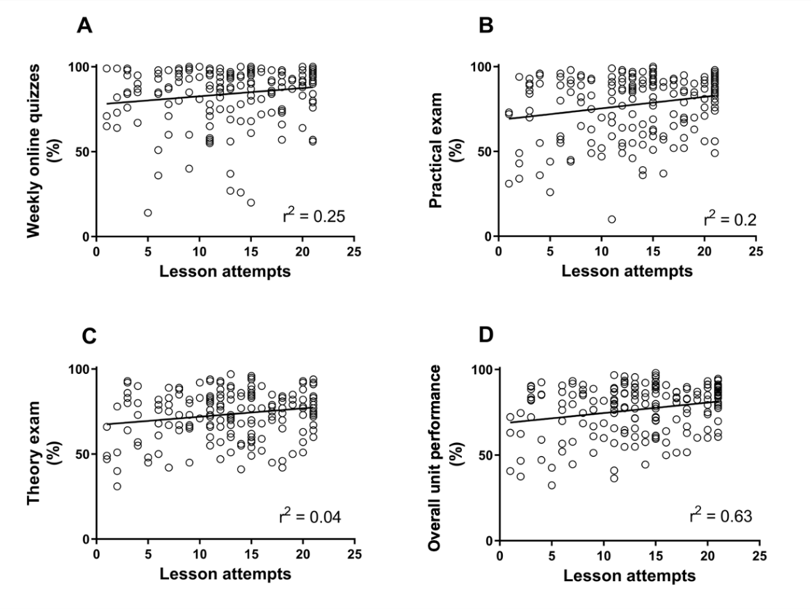

*Note.* This figure demonstrates the Pearson correlation between performance in the unit assessment mark expressed as a percentage and the number of online anatomy lessons attempted. A. Weekly online quizzes. B. Practical exam. C. Theory exam. D. Overall unit performance, p<0.05.

## Survey question responses

When students were asked to rate their understanding before the lesson, on a scale of 1 (being low) to 10 (being very high), the average score was 5.4 out of 10. After completing the lesson, the average rating increased to 7.7 out of 10 (p<0.0001; Figure 3A). The resources were reported to be at just the right level by 85 percent of students (Figure 3B). In total, 70 percent of students strongly agreed that the ‘navigation was simple and straightforward’ and 82 percent of students either agreed or strongly agreed that ‘the online lessons provided an individualised learning environment’ (Figure 4; Questions 1 & 2). Ninety five percent of students reported that ‘The online lessons helped me in my learning’, 86 percent of students found ‘The online lessons were interesting and engaging’ and 93 percent reported that ‘Being able to access the online lessons outside the classroom made them more useful’ (Figure 4; Questions 3-5). Over the 4-year survey period, both questions reported consistently high results that were irrespective of the year of enrolment or the mode of study (data not shown). In response to the question ‘Completing the resources made me feel more confident DURING the laboratory class’, 95 percent of students agreed or strongly agreed while 86 percent of students agreed that ‘The resources were useful as revision tools AFTER the laboratory activity’ (Figure 4; Questions 6 & 7).

**Figure 3.** *Student Responses to the Adaptive Lessons*

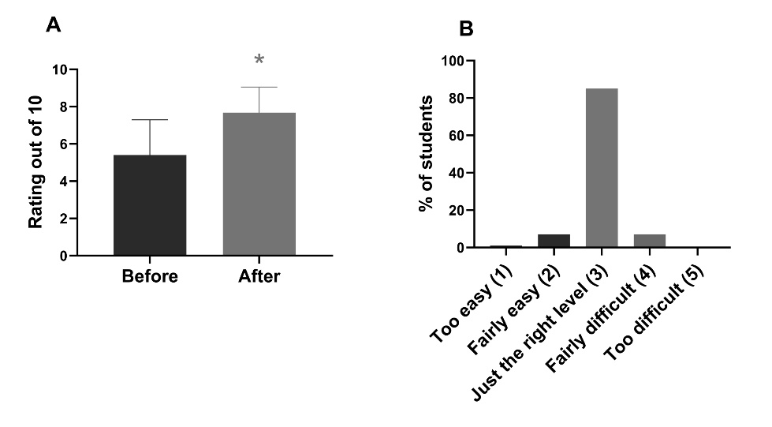

*Note.* A. Students indicated an increased understanding of the topic after completing the online anatomy lessons. B. The online lessons were reported as just the right level of difficulty. *p<0.0001

**Figure 4.** *Student Responses to Survey Questions regarding Impact on Student Experience*

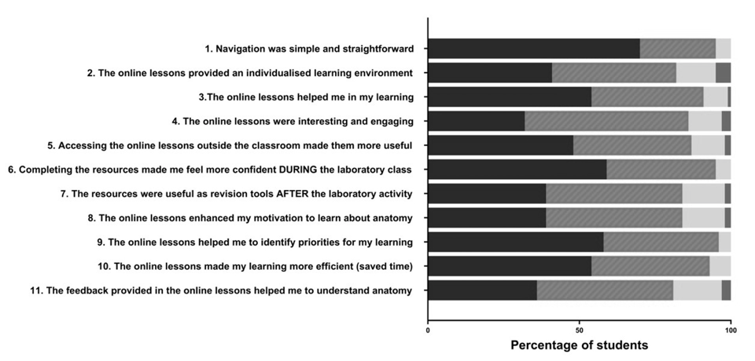

*Note.* Students’ responses to statements regarding various aspects of their learning experience on a scale of 5 (strongly agree, left) to strongly disagree (right).

## Impact of COVID-19

Students' responses to questions regarding motivation, priorities, efficiency and feedback averaged across the four years of the study were all extremely positive (Figure 4; Questions 8-11). However, the responses to all three questions were higher in 2020, during the COVID-19 pandemic, than online or on-campus students in 2016 to 2019. As shown in Figure 5, there was a marked increase in both the average response (top row) and the number of students scoring the question 5 out of 5 (strongly agree, bottom row). In response to the question ‘The online lessons enhanced my motivation to learn about anatomy, 18 percent of online students and 41 percent of on campus students from 2016-2019 responded with strongly agree, which increased to 57 percent of students in 2020 in response to COVID-19 (Figure 5A). Similarly, in response to the question ‘The online lessons helped me to identify priorities for my learning’ 33 percent of online students and 54 percent of on campus students responded with strongly agree, however this number increased to 73 percent of students in response to COVID-19 (Figure 5B).

**F**

**Figure 5.** *Student Responses to Survey Questions regarding Online Lessons*

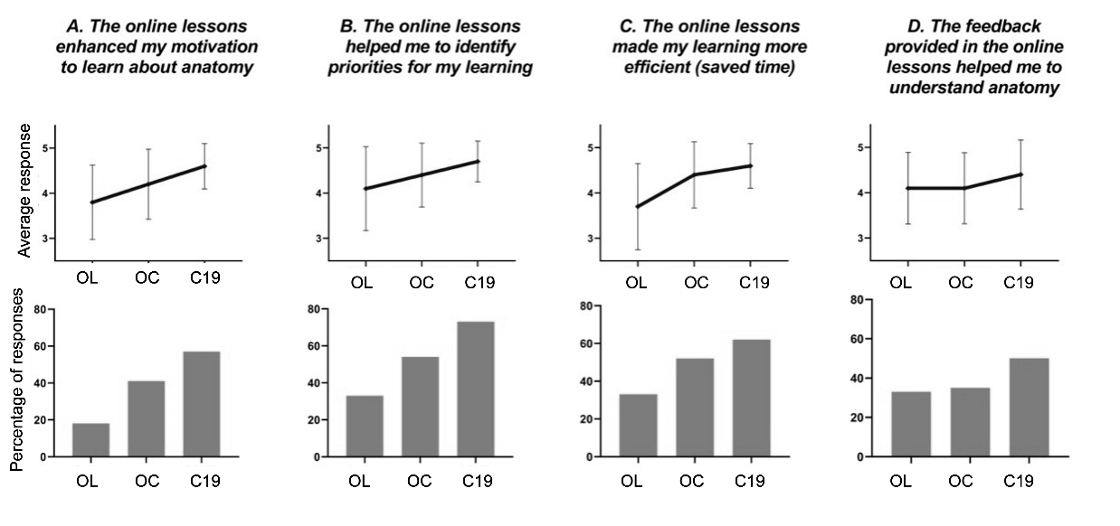

*Note.* Student responses to four questions regarding the online anatomy lesson based on the mode of study: online (OL), on-campus (OC) or during the COVID-19 pandemic (C19). Top row: average response to the 5-point Likert style questions. Bottom row: percentage of students who rated the question 5 (strongly agree) out of 5.

A total of 135 students provided an open-ended response to the question ‘What did you find least useful about the online adaptive lessons?’. The responses were grouped into four themes; engagement, flexibility of learning, student learning, and preparedness for laboratory classes and assessment tasks (Figure 6). Sixty-nine students responded to the question ‘What did you find least useful about the online adaptive lessons?’. Common themes for the least useful aspects of the online adaptive lessons were the need for correct spelling (33 students from across all three modes). One student commented, “The fact that if you spell a word wrong you couldn't get the answer right”. Twenty-six students suggested future improvements such as more cadaveric pictures and questions (9 students) and that the order of the lessons should be randomised (4 students). Another student commented “To give different examples each time you restart the lesson so you don’t get into a habit of memorising what is shown to help broaden my understanding”. A further ten students commented on other aspects of the unit unrelated to the adaptive lessons. The Unit Coordinator provided feedback on the adaptive online lessons in a semi-structured interview (Figure 7).

**Figure 6.** *Feedback from Students on the Online Lessons*

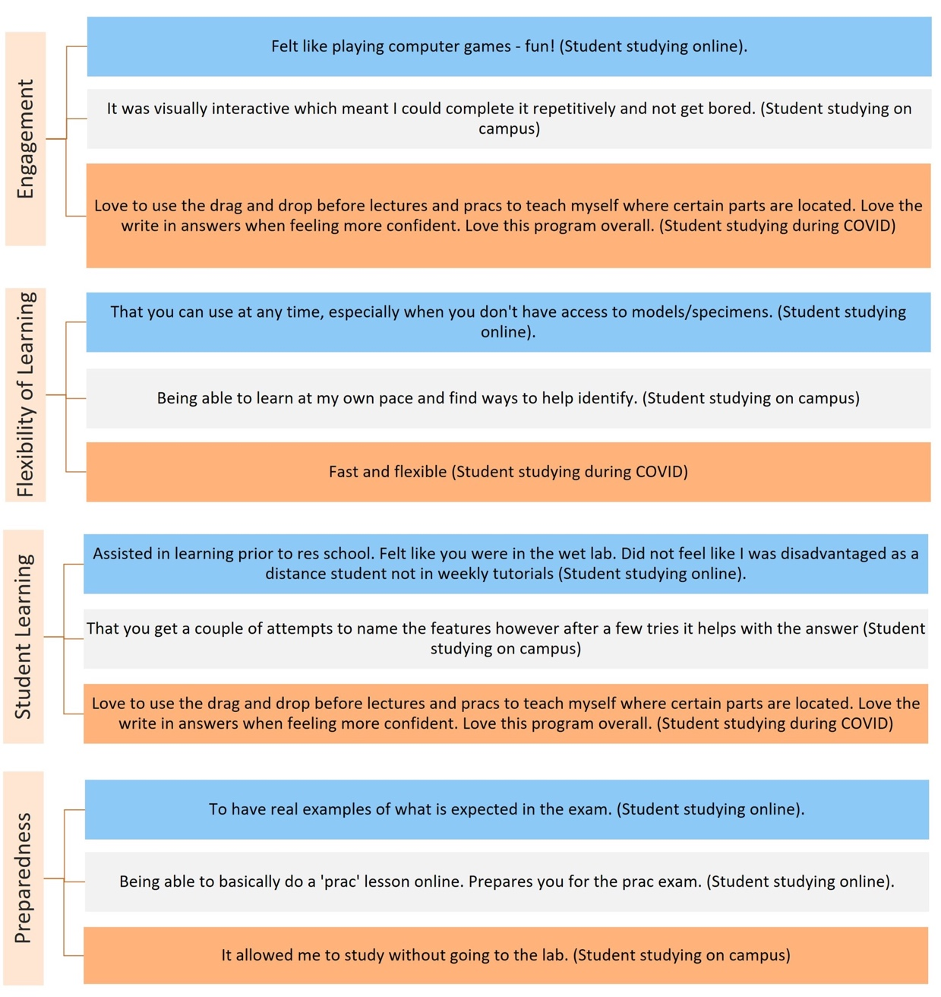

*Note.* Student responses to the question ‘What did you find least useful about the online adaptive lessons?’

**Figure 7.** *Feedback from the Unit Coordinator*

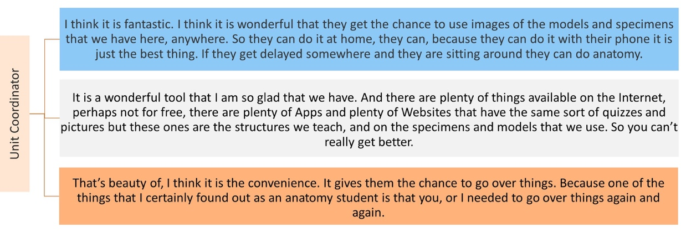

*Note.* Three themes were identified from the transcription of the semi-structured interview with the Unit Coordinator including feelings about the lessons, expectations for the lessons, and feedback about the lessons.

# Discussion

Universities are looking for ways to increase student engagement to increase overall student success. Adaptive technologies such as online adaptive learning platforms can be used to facilitate student learning and increase student engagement (Yakin & Linden, 2021). In this study, the efficacy of adaptive learning resources in teaching first-year anatomy is supported by the high level of engagement with the lessons and students’ self-reported improvements in their learning and exam preparedness. The online lessons were self-paced and not part of unit requirements. Due to the intuitive design, the lessons were easy to navigate and could be repeated as many times as the student would like. Students overwhelmingly reported that the lessons were engaging and increased their understanding and exam preparedness.

The adaptive learning lessons were evaluated in 2016, 2017, 2019 and 2020, and during this time there were multiple staff teaching this unit. Analysis of the number of lessons attempted shows sustained and consistent high engagement, irrespective of the mode of study (online or on-campus) or in response to the rapid move to online study for all students in 2020. Student feedback indicated that the high level of engagement with the lessons was a key reason for their success. Despite this, some students who did not attempt the online lesions performed well in assessments. In future evaluations, student focus groups could be consulted on their experiences with various other methods of studying anatomy.

Staying motivated was the most difficult aspect of the transition to online students (Means & Neisler, 2020). In the current study, students’ positive feedback regarding motivation was consistently high from 2016 to 2019. However, in 2020, in response to COVID-19, there was a 320 percent increase in the proportion of students who strongly agreed that the online lessons enhanced their motivation compared with online students prior to 2020 (57% vs 18%), who completed the practical component of the unit in a 1-week intensive practical class. It has been well described that unit progress rates (the percentage of students receiving a passing grade) and attrition are higher in online cohorts across the sector (Cupitt & Golshan, 2015). In the current study, there is little evidence to suggest that students in 2020 were greatly disadvantaged.

The learning outcomes of the online adaptive lessons were closely aligned with the expectations of the practical exam that was worth 50% of the overall unit mark. In the practical exam, students were asked to correctly identify 100 (of a possible 500) human anatomy structures. There was a significant positive correlation between the score that students received in the final adaptive lesson (a practice practical exam) and their score in the practical exam. Student grades increased proportionally to student engagement with the adaptive learning lessons and students reported increased learning that was linked to increased preparedness for practical classes. This study contributes to previous findings that demonstrate a positive relationship between the use of learning technology, student engagement and learning outcomes (Wells et al., 2008; Wong, 2013).

Traditionally, success in first-year anatomy required students to spend considerable time examining specimens in the laboratory to be able to recall anatomical structures and these repetitive lessons in learning anatomy have been shown to be advantageous (Estai, 2016; Kooloos et al., 2020). Limitations on how much time students can spend revising anatomy in the laboratory, and staffing constraints, have led to developments in online technologies. However, due to the practical nature, it is likely that the best way to teach anatomy is by combining multiple pedagogical resources (Estai, 2016).

Providing instant feedback and implementing UDL has been shown to benefit students learning anatomy (Baashar et al., 2023; Dempsey et al., 2024). The online lessons in our study increased flexibility in studying regarding timing, place, repeatability and speed, while providing instant feedback. In this study, students commented on their motivation and curiosity to repeat the lessons. Repetition for learning is an important aspect as to the success of the lessons and was highlighted in the feedback from the unit coordinator who said that “...one of the things that I certainly found out as an anatomy student is that you, or I needed to go over things again and again”. Students repeatedly commented on the flexibility of the resource, and how it allowed them to prepare for the practical exam without having to go to the laboratory.

One of the limitations to extending laboratory hours for self-guided study outside of class time is the lack of teaching staff to provide students guidance and feedback. Due to the nature of anatomical variations between specimens, students may spend a substantial amount of time identifying one structure, or incorrectly identify structures on a specimen without receiving feedback. In the first three years of the study, both online and on campus students commented that the feedback provided in the lessons helped them to understand anatomy. However, the number of students scoring this question a 5 (strongly agree) increased by 140 percent in 2020 when all face-to-face classes were moved online. The adaptive lessons helped students identify strengths and weaknesses in their knowledge, and students could then target those weaknesses when instruction was again available in the laboratory, making study time more efficient.

## Limitations and future improvements

In the current study, a considerable amount of time was spent interrogating the analytic information collected by the Smart Sparrow platform. Limitations were identified with the data including errors with the downloaded timestamping and the average time spent on the lesson was skewed due to lessons not timing out, with many attempts reported in excess of 6 hours to complete. As students were able to attempt each section as many times as they liked and then be directed back to the menu screen, a more useful metric may have been time spent on the lesson per log in. As the number of times a student completed the lesson from the analytics was also not accurate, a survey question was included. There was a similar issue with the score, as instead of a percentage, the score was the number of correct answers. If a student repeated sections, the score would continue to increase above the maximum and did not provide a meaningful number.

As outlined previously, the use of online adaptive learning has limitations such as reduced access to synchronous support and limited teacher and peer interactions (Molenaar et al., 2012; Wu et al., 2018). During the COVID-19 pandemic, teaching academics developed resources and implemented online technologies to support student learning. However, the rapid move to online learning did not afford teaching academics, or higher education institutions, time to research, implement and evaluate best practice in online teaching (Hollister et al., 2022), particularly for courses typically involving compulsory on campus and practical classes to deliver the content. It is well-recognised that hybrid learning can increase the workload of academic teaching staff who often need to adapt teaching to accommodate both modalities while maintaining student engagement and course quality.

We found that implementing adaptive learning successfully requires responsiveness, targeted design, scaffolding, and a commitment to continuous improvement. Different lesson formats were trialled and building student feedback early in the process was crucial to improving the lessons in real time. The final lesson format most closely resembled formative assessments. The importance of formative assessment has been shown previously to improve performance in summative assessment in both anatomy (Kingston et al., 2023) and more broadly in higher education (Leenknecht et al., 2021). Based on student feedback the lesson structures were redesigned to include functional questions in addition to the labelling of structures. These questions will have a similar format to the questions from the theory exam and weekly online quizzes. Despite some negative feedback from students regarding the need for correct spelling, the course directors indicated the importance of correct spelling for future allied health professionals. More hints regarding correct spelling were built into the adaptive feedback lessons.

# Conclusion

Our findings demonstrate that students showed high engagement and increased understanding following the use of the adaptive learning lessons in studying first year anatomy. This is evident through the positive correlation between engagement with the learning resource and students’ grades. In addition, students expressed appreciation for the individualised, flexible and engaging nature of the learning technology. In 2020, when face-to-face classes were cancelled, online adaptive resources were used to rapidly (and temporarily) replace laboratory classes. Future work will evaluate the use of adaptive learning resources in providing customised and discipline-specific feedback to students and explore further enhancements to learning analytics to address deficiencies in available analytics identified through the implementation of the technology.

# Acknowledgements

The authors disclose that they have no actual or perceived conflicts of interest. The authors disclose that they have not received any funding for this manuscript beyond resourcing for academic time at their respective university. The authors have not used artificial intelligence in the ideation, design, or write-up of this research as per Crawford et al. (2023). The authors declare that the ethical clearance for this study had been approved by the Human Research Ethics Committee of the university where the authors work (Protocol numbers EC00116 & H16057). The authors list the following credit contributions: Kelly Linden: conceptualisation, investigation, data curation, methodology, visualisation, writing (original draft, review and editing). Sarah Teakel: writing (original draft, review and editing).

The authors would like to express our gratitude to the participants for their time and valuable insights, and the editor, Associate Professor Rachel Fitzgerald for her constructive and helpful comments. And finally, the authors would like to thank Mr Adam Brett and Dr Louise Pemberton for their support in creating the adaptive lessons.

## Disclosure statement

The authors report no conflicts of interest. The authors alone are responsible for the content and writing of the article.

## Data Availability

The data that support the findings of this study are available from the corresponding author upon request.

# References

Alkhowailed, M. S., Rasheed, Z., Shariq, A., Elzainy, A., El Sadik, A., Alkhamiss, A., Alsolai, A. M., Alduraibi, S. K., Alduraibi, A., Alamro, A., Alhomaidan, H. T., & Al Abdulmonem, W. (2020). Digitalization plan in medical education during COVID-19 lockdown. *Informatics in medicine unlocked*, *20*, 100432-100432. https://doi.org/10.1016/j.imu.2020.100432

Ang, E. T., Chan, J. M., Gopal, V., & Li Shia, N. (2018). Gamifying anatomy education. *Clinical anatomy (New York, N.Y.)*, *31*(7), 997-1005. https://doi.org/10.1002/ca.23249

Antoninis, M., April, D., Barakat, B., Bella, N., D’Addio, A. C., Eck, M., Endrizzi, F., Joshi, P., Kubacka, K., McWilliam, A., Murakami, Y., Smith, W., Stipanovic, L., Vidarte, R., & Zekrya, L. (2020). All means all: An introduction to the 2020 Global Education Monitoring Report on inclusion. *Prospects (Paris)*, *49*(3-4), 103-109. https://doi.org/10.1007/s11125-020-09505-x

Baashar, A., Kumar, R. S., Akhtar, S. M. I., Alyousif, S. M., Alhassan, A. I., & Townsi, N. (2023). Impact of Audience Response System in Enhancing Teaching of Anatomy and Physiology for Health Sciences Students at King Saud bin Abdulaziz University for Health Sciences. *Advances in medical education and practice*, *14*, 421-432. https://doi.org/10.2147/AMEP.S397621

Brassett, C., Cosker, T., Davies, D. C., Dockery, P., Gillingwater, T. H., Lee, T. C., Milz, S., Parson, S. H., Quondamatteo, F., & Wilkinson, T. (2020). COVID‐19 and anatomy: Stimulus and initial response. *Journal of anatomy*, *237*(3), 393-403. https://doi.org/10.1111/joa.13274

Bruno, P. A., Love Green, J. K., Illerbrun, S. L., Holness, D. A., Illerbrun, S. J., Haus, K. A., Poirier, S. M., & Sveinson, K. L. (2016). Students helping students: Evaluating a pilot program of peer teaching for an undergraduate course in human anatomy. *Anatomical sciences education*, *9*(2), 132-142. https://doi.org/10.1002/ase.1543

Chen, C. (2010). Information visualization. *Wiley Interdisciplinary Reviews: Computational Statistics*, *2*(4), 387-403. https://doi.org/doi:10.1002/wics.89

Crawford, J., Cowling, M., Ashton-Hay, S., Kelder, J. A., Middleton, R., & Wilson, G. S. (2023). Artificial intelligence and authorship editor policy: ChatGPT, bard bing AI, and beyond. *Journal of University Teaching & Learning Practice, 20*(5), 1. <https://doi.org/10.53761/1.20.5.01>

Cupitt, C., & Golshan, N. (2015). Participation in higher education online: Demographics, motivators, and grit. STARS Conference,

de Jong, T., Linn, M. C., & Zacharia, Z. C. (2013). Physical and Virtual Laboratories in Science and Engineering Education. *Science*, *340*(6130), 305-308. https://doi.org/10.1126/science.1230579

Dempsey, A. M. K., Hunt, E., Nolan, Y. M., & Lone, M. (2024). Healthcare students’ awareness of Universal Design for Learning (UDL) in anatomy curricula: An Irish single institution-based study. *Translational research in anatomy*, *37*, 100316. https://doi.org/10.1016/j.tria.2024.100316

Diaz, C. M., Linden, K., & Solyali, V. (2021). Novel and Innovative Approaches to Teaching Human Anatomy Classes in an Online Environment During a Pandemic. *Medical science educator*, *31*(5), 1703-1713. https://doi.org/10.1007/s40670-021-01363-2

Drake, R. L., McBride, J. M., Lachman, N., & Pawlina, W. (2009). Medical education in the anatomical sciences: The winds of change continue to blow. *Anatomical sciences education*, *2*(6), 253-259. https://doi.org/10.1002/ase.117

Estai, M., & Bunt, S. (2016). Best teaching practices in anatomy education: A critical review. *Annals of anatomy*, *208*(November 2016), 151-157.

Gale, N. K., Heath, G., Cameron, E., Rashid, S., & Redwood, S. (2013). Using the framework method for the analysis of qualitative data in multi-disciplinary health research. *BMC medical research methodology*, *13*(1), 117-117. https://doi.org/10.1186/1471-2288-13-117

García-Campos, M.-D., Canabal, C., & Alba-Pastor, C. (2020). Executive functions in universal design for learning: moving towards inclusive education. *International journal of inclusive education*, *24*(6), 660-674. https://doi.org/10.1080/13603116.2018.1474955

Hancock, D., Williams, M., & Taylor, A. (1998). Psychological impact of cadavers and prosections on physiotherapy and occupational therapy students. *Australian journal of physiotherapy*, *44*(4), 247-255. https://doi.org/10.1016/S0004-9514(14)60384-6

Hollister, B., Nair, P., Hill-Lindsay, S., & Chukoskie, L. (2022). Engagement in Online Learning: Student Attitudes and Behavior During COVID-19. *Frontiers in education (Lausanne)*, *7*. https://doi.org/10.3389/feduc.2022.851019

Kahn, P. E. (2014). Theorising student engagement in higher education. *British Educational Research Journal*, *40*(6), 1005-1018. https://doi.org/10.1002/berj.3121

Khanal, L., Giri, J., Shah, S., Koirala, S., & Rimal, J. (2019). Influence of learning-style preferences in academic performance in the subject of human anatomy: an institution-based study among preclinical medical students. *Advances in medical education and practice*, *10*, 343-355. https://doi.org/10.2147/AMEP.S198878

Kift, S. (2015). A decade of transition pedagogy: A quantum leap in conceptualising the first year experience. *HERDSA Review of Higher Education*, *2*(1), 51-86. https://doi.org/https://altf.org/wp-content/uploads/2019/03/HERDSARHE2015v02p51-1-1.pdf

Kingston, A. K., Garofalo, E. M., Cardoza, K., & Fisher, R. E. (2023). Designing formative assessments to improve anatomy exam performance. *Anatomical sciences education*, *16*(5), 989-1003. https://doi.org/10.1002/ase.2279

Kooloos, J. G. M., Bergman, E. M., Scheffers, M., Schepens-Franke, A. N., & Vorstenbosch, M. A. T. M. (2020). The Effect of Passive and Active Education Methods Applied in Repetition Activities on the Retention of Anatomical Knowledge. *Anatomical sciences education*, *13*(4), 458-466. https://doi.org/10.1002/ase.1924

Langfield, T., Colthorpe, K., & Ainscough, L. (2018). Online instructional anatomy videos : Student usage, self-efficacy, and performance in upper limb regional anatomy assessment. *Anatomical sciences education*, *11*(5), 461-470. https://doi.org/10.1002/ase.1756

Leenknecht, M., Wijnia, L., Köhlen, M., Fryer, L., Rikers, R., & Loyens, S. (2021). Formative assessment as practice: the role of students' motivation. *Assessment and evaluation in higher education*, *46*(2), 236-255. https://doi.org/10.1080/02602938.2020.1765228

Lemos, G. A., Araújo, D. N., de Lima, F. J. C., & Bispo, R. F. M. (2021). Human anatomy education and management of anatomic specimens during and after COVID-19 pandemic: Ethical, legal and biosafety aspects. *Annals of anatomy*, *233*, 151608-151608. https://doi.org/10.1016/j.aanat.2020.151608

Linden, K., Webster, L., Pemberton, L. & Davison, W.R. (2018). Can we calm first-year student’s “neuroscience anxiety” with adaptive learning resources? A pilot study. In M. Campbell, J. Willems, C. Adachi, D. Blake, I. Doherty, S. Krishnan, S. Macfarlane, L. Ngo, M. O’Donnell, S. Palmer, L. Riddell, I. Story, H. Suri & J. Tai (Eds.), Open Oceans: Learning without borders. Proceedings ASCILITE 2018 Geelong (pp. 451-455).

Longhurst, G. J., Stone, D. M., Dulohery, K., Scully, D., Campbell, T., & Smith, C. F. (2020). Strength, Weakness, Opportunity, Threat (SWOT) Analysis of the Adaptations to Anatomical Education in the United Kingdom and Republic of Ireland in Response to the Covid‐19 Pandemic. *Anatomical sciences education*, *13*(3), 301-311. https://doi.org/10.1002/ase.1967

Means, B., & Neisler, J. (2020). *Suddenly online: A national survey of undergraduates during the COVID-19 pandemic*. https://digitalpromise.dspacedirect.org/bitstream/handle/20.500.12265/98/DPSuddenlyOnlineReportJuly2020.pdf?sequence=3&isAllowed=yt

Mirata, V., Hirt, F., Bergamin, P., & van der Westhuizen, C. (2020). Challenges and contexts in establishing adaptive learning in higher education: findings from a Delphi study. *International Journal of Educational Technology in Higher Education*, *17*(1), 1-25. https://doi.org/10.1186/s41239-020-00209-y

Molenaar, I., Roda, C., van Boxtel, C., & Sleegers, P. (2012). Dynamic scaffolding of socially regulated learning in a computer-based learning environment. *Computers and education*, *59*(2), 515-523. https://doi.org/10.1016/j.compedu.2011.12.006

Morze, N., Varchenko-Trotsenko, L., Terletska, T., & Smyrnova-Trybulska, E. (2021). Implementation of adaptive learning at higher education institutions by means of Moodle LMS. *Journal of physics. Conference series*, *1840*(1), 12062. https://doi.org/10.1088/1742-6596/1840/1/012062

New Media Consortium Horizon Project. (2018). *NMC Horizon Report Preview*. EDUCAUSE. https://library.educause.edu/resources/2018/4/nmc-horizon-report-preview-2018

Oxman, S., & Wong, W. (2014). White paper: Adaptive learning systems. In D. X. D. E. G. I. E. Solutions (Ed.): Integrated Education Solutions.

Patel, K., & Moxham, B. (2006). Attitudes of professional anatomists to curricular change. *Clinical Anatomy*, *19*(2), 132-141. https://doi.org/doi:10.1002/ca.20249

Polly, P., Marcus, N., Maguire, D., Belinson, Z., & Velan, G. (2014). Evaluation of an adaptive virtual laboratory environment using Western Blotting for diagnosis of disease [journal article]. *BMC Medical Education*, *14*(1), 222. https://doi.org/10.1186/1472-6920-14-222

Sinatra, G. M., Heddy, B. C., & Lombardi, D. (2015). The Challenges of Defining and Measuring Student Engagement in Science. *Educational Psychologist*, *50*(1), 1-13. https://doi.org/10.1080/00461520.2014.1002924

Wang, S., Wang, F., Zhu, Z., Wang, J., Tran, T., & Du, Z. (2024). Artificial intelligence in education: A systematic literature review. *Expert systems with applications*, *252*, 124167. https://doi.org/10.1016/j.eswa.2024.124167

Wells, P., De Lange, P., & Fieger, P. (2008). Integrating a virtual learning environment into a second-year accounting course: determinants of overall student perception. *Accounting & Finance*, *48*(3), 503-518. https://doi.org/doi:10.1111/j.1467-629X.2007.00249.x

White, G. (2020). Adaptive Learning Technology Relationship with Student Learning Outcomes. *Journal of information technology education*, *19*, 113-130. https://doi.org/10.28945/4526

Wong, L. (2013). *Student Engagement with Online Resources and Its Impact on Learning Outcomes* Proceedings of the Informing Science and Information Technology Education Conference 2013, https://www.learntechlib.org/p/114687

Wong, V., Smith, A., Hawking, N., Kumar, R., Young, N., Kyaw, M., & Velan, G. (2015). Adaptive tutorials versus web-based resources in radiology: A mixed methods comparison of efficacy and student engagement. *Academic Radiology*, *22*(10), 1299-1307. https://doi.org/https://doi.org/10.1016/j.acra.2015.07.002

Wu, C.-H., Chen, Y.-S., & Chen, T.-g. (2018). An Adaptive e-Learning System for Enhancing Learning Performance: Based on Dynamic Scaffolding Theory. *Eurasia journal of mathematics, science and technology education*, *14*(3). https://doi.org/10.12973/ejmste/81061

Yakin, M., & Linden, K. (2021). Adaptive e-learning platforms can improve student performance and engagement in dental education. *Journal of Dental Education*, *85*(7), 1309-1315. https://doi.org/https://doi.org/10.1002/jdd.12609